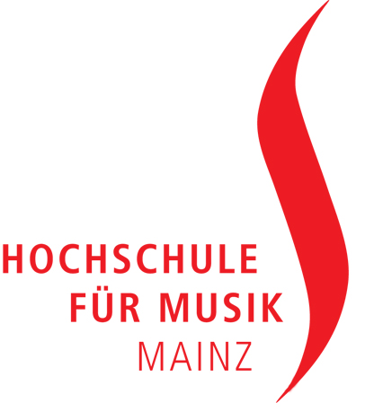

Press Release

"Organ Plus" Composition Competition: Winners determined

Premiere of the winning composition in the framework of the
International Organ Competition of the Hochschule für Musik Mainz in October

(Mainz, April 8th 2010, pfr/sp) A two-movement work for organ and brass sextet, duration 8 to 10 minutes, was the challenge of the composition competition "Organ Plus", which was announced last year by the Hochschule für Musik in Mainz. From a total of thirty-three compositions submitted, the jury, chaired by the Dean of the School of Music, Prof. Dr. Jürgen Blume chose the three winning works: The first prize was awarded to Dominik Susteck (Cologne) for his work "Between Worlds." The second prize was awarded to Maximilian Schnaus (Hannover) for his composition "The Cloud Factory" and the third prize goes to István Láng (Budapest) for his work "Ottorgano." All three winning compositions will be printed, published and distributed by the Mainz ARE Music Publishing Company.

"I am very pleased with the great responses to our competition posting and the high quality of the entries," said Prof. Blume. The awarded work, "Between Worlds" by Dominik Susteck, is a very avant-garde and precisely worked out, excellent sounding piece. We are very excited about it and are looking forward to it’s premiere at the International Organ Competition in Mainz in October."

The jury consisted of Prof. Dr. Jürgen Blume (Hochschule für Musik Mainz, Chair), Prof. Thierry Escaich (Conservatoire Supérieur de Paris), Prof. Vinko Globokar (composer and trombonist), Prof. Alfred Müller (Professor for improvisation at the Hochschule für Musik Mainz), and Prof. Zsigmond Szathmáry (retired Professor for organ at the Musikhochschule in Freiburg).

The reason for the anouncement of the composition, as well as organ competition, is a newly built concert organ, which will be installed inside the organ hall at the Hochschule für Musik Mainz during the course of the summer term by the company Goll (Luzern).

Sixty-six young organists from all over Europe, the USA, South Korea and Japan had applied for the organ Competition by the end of February. Twenty-four candidates have qualified to participate through a pre-selection. From October 10th through October 16th they will come to Mainz in order to compete in the contest for the best interpretation. A total of three rounds of the competition will be held at the new Goll Organ of the Hochschule für Musik Mainz and at the Cavaillé-Coll Organ of St. Bernard in Mainz-Bretzenheim. The competition is under the auspices of
domination by Prime Minister Kurt Beck and the contest director is Prof. Eduard Wollitz. All rounds are open to the public. "The program of the organ competition offers not only interpretation courses for participants as well as students from the Hochschule für Musik Mainz, it also includes concert performances by the jurors performing on different organs in and around Mainz." said Gerhard Gnann, along with his colleague Hans-Jürgen Kaiser, the initiator of the composition and organ competition. Both are professors of church music at the Hochschule für Musik in Mainz. They are both very proud to present the following prestigious international artists who will perform during the course of the program: Guy Bovet (Switzerland), Bjorn Boysen (Norway), Emmanuel le Divellec (Switzerland), Hans Fagius (Denmark), Jacques van Oortmerssen (Netherlands), Klemens Schnorr (Germany) and Jozef Serafin (Poland). A comprehensive program guide with all information about the organ competition will be released this summer.

The Composition and Organ Competition will be supported and sponsored by the Protestant Church in Hessen and Nassau, by Freunde der Johannes Gutenberg Universität Mainz e.V. (Friends Club of the Johannes Gutenberg University in Mainz), and also supported by the Diocese of Mainz, by the Freundeskreis der Musikhochschule Mainz e.V. (Friends Circle of the Hochschule für Musik in Mainz) and by the organ builder companies Goll (Lucerne) and Rieger (Schwarzach).
"We are very grateful for this commitment, without which the realization of the contests would not be possible," said Prof. Hans-Jürgen Kaiser. With a new organ recital series following the contest, the new Goll-Organ will be presented to a wide audience.

Contact Information
Dr. Kristina Pfarr
Hochschule für Musik
Johannes Gutenberg-Universität Mainz
Tel. +49 6131 39-28008
Fax +49 6131 39-28012
E-Mail: pfarr@uni-mainz.de
www.orgelwettbewerb.hfm-mainz.de

3/3

